<< EBIZ WEB S/R REGISTER CORRECTION >>

*.This web page is for retrieving or registering or updating S/R

*.Retrieving S/R work
1. Retrieve page Main screen shoot
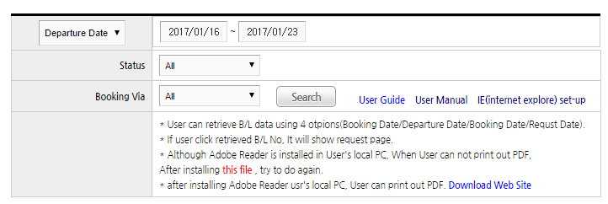

-.1.1 User can retrieve S/R data using query option
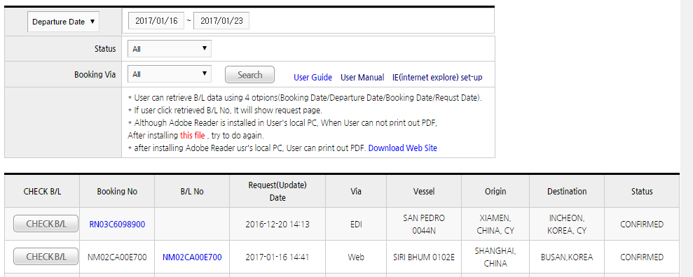
-.1.2 first query option
If User select data option, can use period items (from ~ to date)
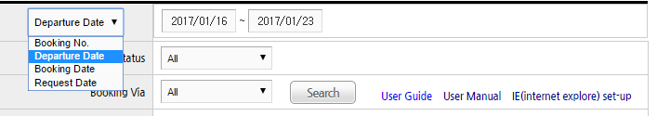
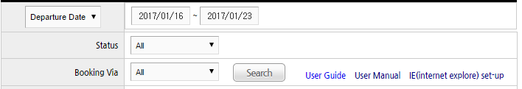

-.1.3 Use Status option
All => All status
Submit => Status that booking data is confirmed
Draft => Status that user save as "TEMPORARY SAVE" (= before submit S/R)
Processing => Status that Heung-a stafff need to confirm
Confirmed => Status that user submit S/R (final confirm)
Rejected => Status that Heung-a stafff rejcet for user request
Closed => Status after Document closing
Specail Not Approved => Status that Specail CNTR is not approved
(Danger/Reefer/Awkward booking need approval spearately)

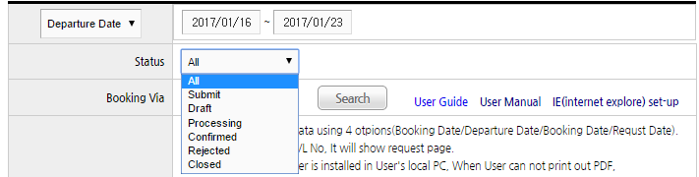

-.1.4 User can select Booking Via option
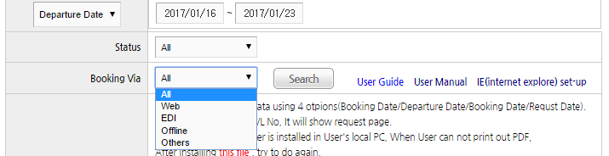

*.Initial register work

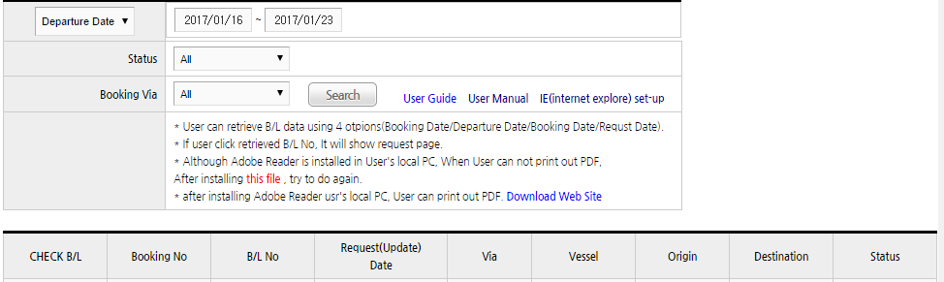

2. Main screen shoot
(SUBMIT status => after Heung-a agent staff confirmed booking data )
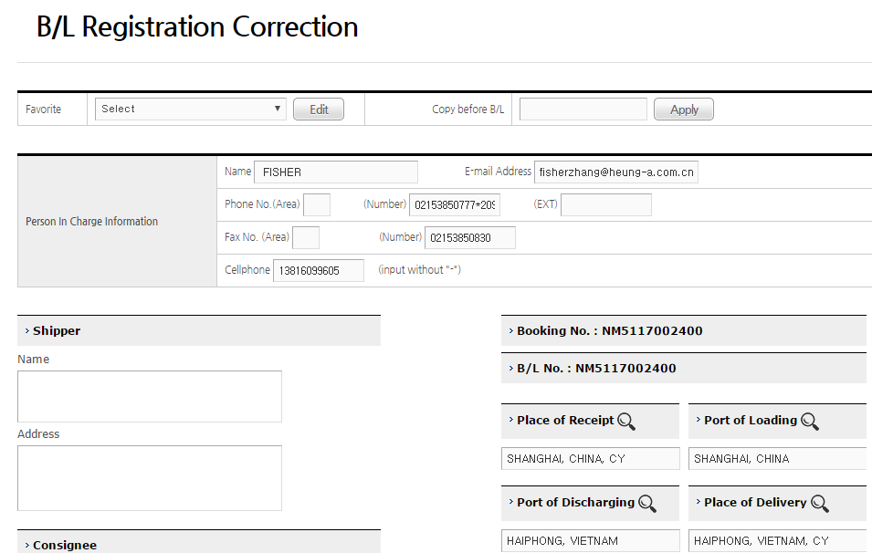
8.Port
5.Shipper
3.Apply
2.Edit
1.Select
6.Consignee
4.PIC
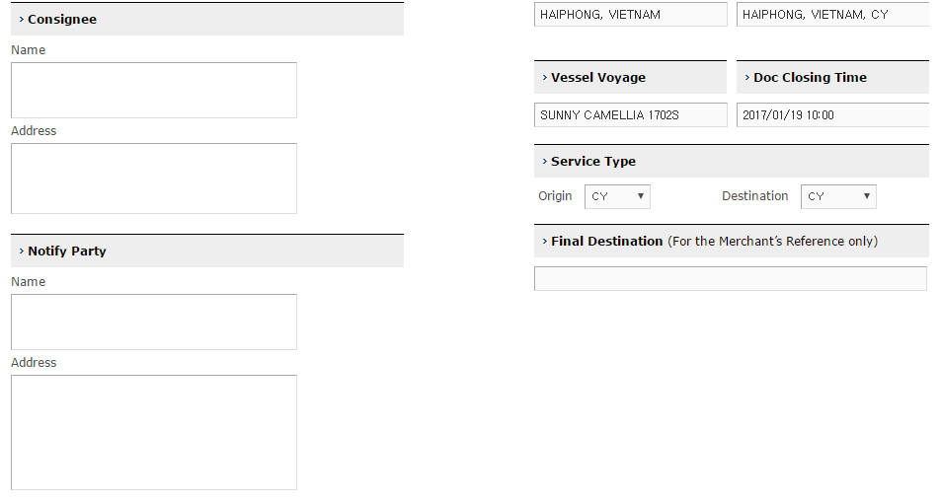
9.Vessel Voyage
10. Final Destination
7.Notify
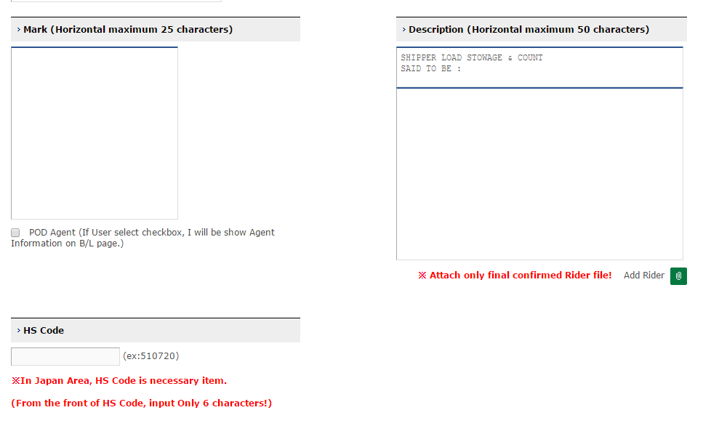
13.HS Code
12.Description
11.Mark
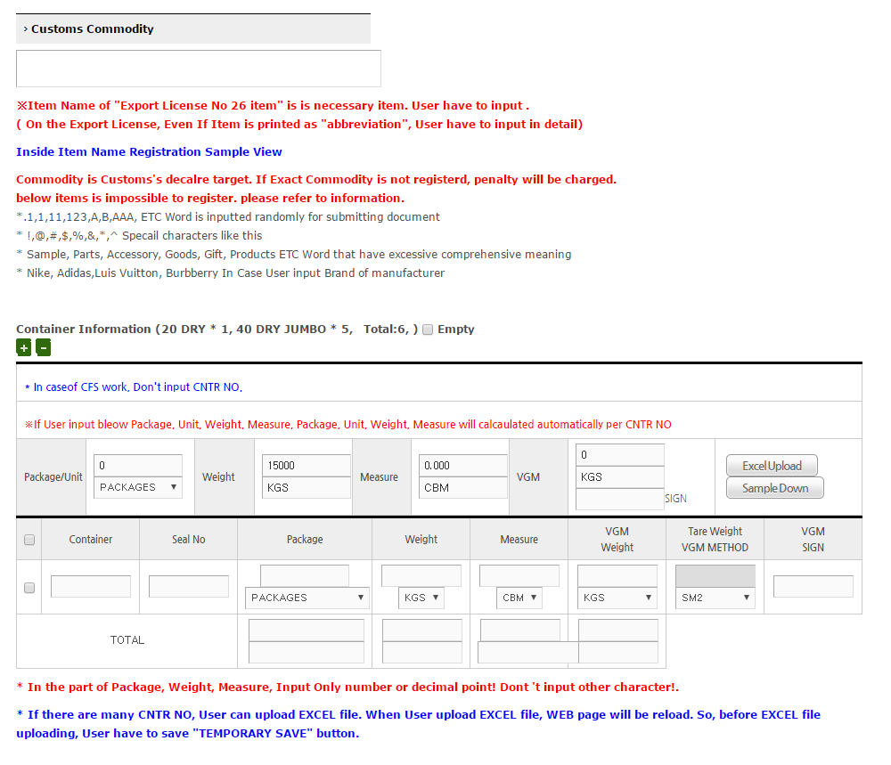
15. Container (plus / minus icon)
18.Excel Upload
17. Conatiner NO
16. Container Total section
14.Commodity

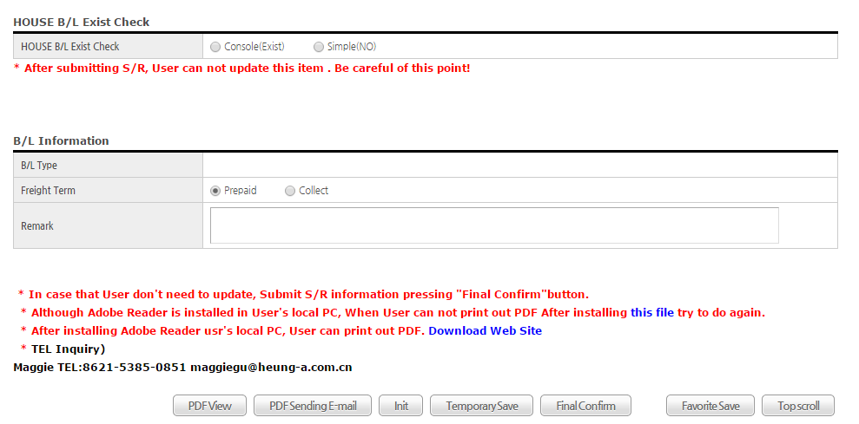
21.Lower buttons
19.House B/L Check
20.Freight Term
-.2.1 Select (Favorite)
-.User can select favorite to want . If user select item, will be applied on the page

-.2.2 Edit (Favorite)
-.If user press “Edit” button, will be moved “S/R Favorite” page

-.2.3 Apply (using Copy before B/L NO )
-.User can use get before B/L
-.After input before B/L NO, press “Apply” button

-.2.4 PIC(person in charge of)
-.This information will be set automatically by log-in user information

-.2.5 Shipper
-.Shipper input line limit => name 2 lines, Address 6 lines is limited

-.2.6 Consignee
-.Consingnee input line limit => name 2lines, Address 6 lines is limited

-.2.7 Notify
-.Notify input line limit => name 2lines, Address 6 lines is limited

-.2.8 Port
-.User can not input port name
-.Select pressing reading glasses icon
-.If there is no data on the pop-up list, request to register to Headquarter Staff
(emp@heung-a.co.kr Headquarter export team e-mail )
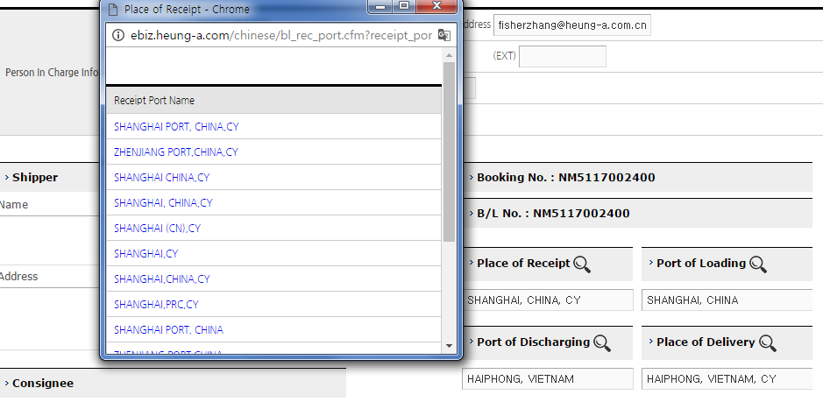

-.2.9 Vessel Voyage
-.User can not update this item

-.2.10 Final Destination
-.Input freely

-.2.11 Mark
-.Input freely

-.2.12 Description
-.Input freely

-.2.13 HS Code
-.Input HS code of Cargo

-.2.14 Commodity
-.Input Commodity item

-.2.15 Container (plus / minus icon)
-.plus icon
:If User press “+” icon, container record will be added
-.minus icon
:After cheking checkbox of record that user want to delete,
If User press “-“ icon, container record will be deleted
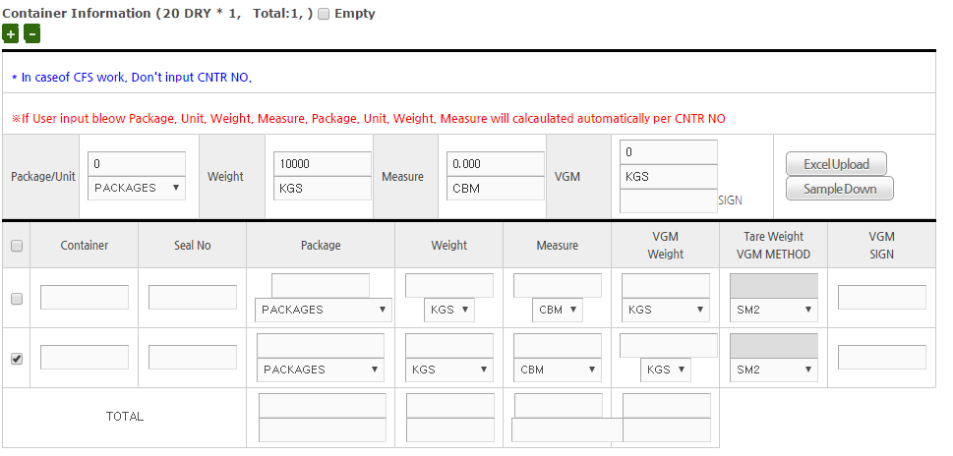

-.2.16 Container Total section
-.If User input total number in the header section(total), will be divided automatically

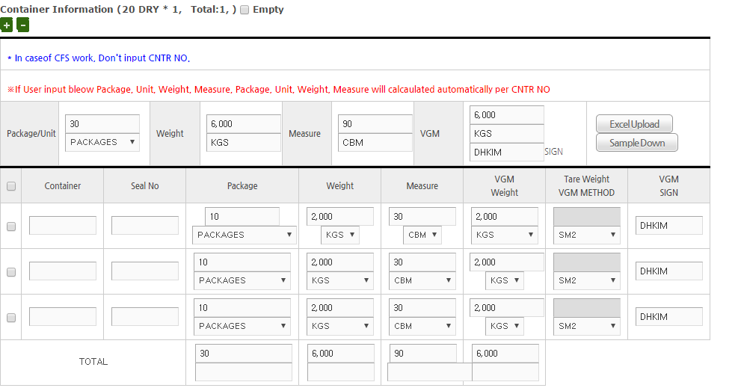

-.2.17 Container NO
-.Input Container Information (NO, seal NO, package, weight, measure )

-.2.18 Excel Upload
-.In case of many container list, user can upload excel
-.First of all, user have to download for uploading excel
-.and then, upload pressing “Excel Upload” button
(but, I will refresh webpage. Highly recommended save data before uploading )

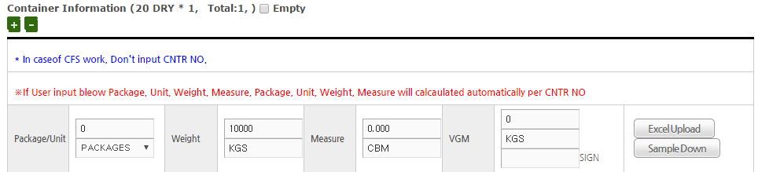

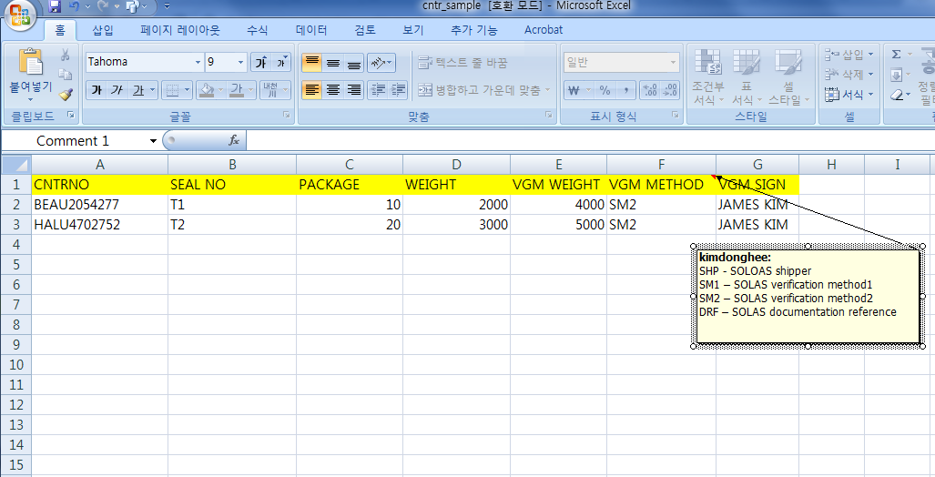
User have to input like same format
(CNTR NO / SEAL_NO / PACKAGE/ WEIGHT /
VGM WEIGHT / VGM METHOD / VGM SIGN)
Don’t input “,” comma character!!!

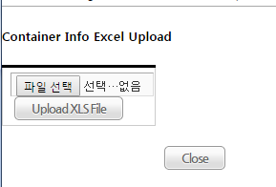
-.2.19 House B/L Check
-.Select House B/L exist

-.2.20 Freight Term
-.Select whether prepaid or collect

-.2.21 Lower buttons
1) PDF View
: User can see S/R data that input. If press button, will be opened PDF popup

2) PDF sending E-mail
:If user click this button, will send to user’s e-mail address with attached PDF

3) Init
:If user click this button, page will be cleared

4) Temporary Save
: Before Final Confirm(submit S/R) , User can save using this button
And then, User can print out Check B/L using temporary S/R data

5) Final Confirm
*.Before final confirm(submit S/R), highly recommended to use “Temporary Save”
And then, Check data if all data is ok
*.If user finish all work to check S/R information whether it’s fine or not,
Press this button
*.Restriction
-.After user booked as “COC” initially, if user input container NO
that not exists as COC in Heung-a system, user can not save
-.If user input container size type is different form container size type that booked initially,user can not save

6) Favorite Save
: When User want to save as user’s “Favorite”. Use this function

*.After final confirm – update work
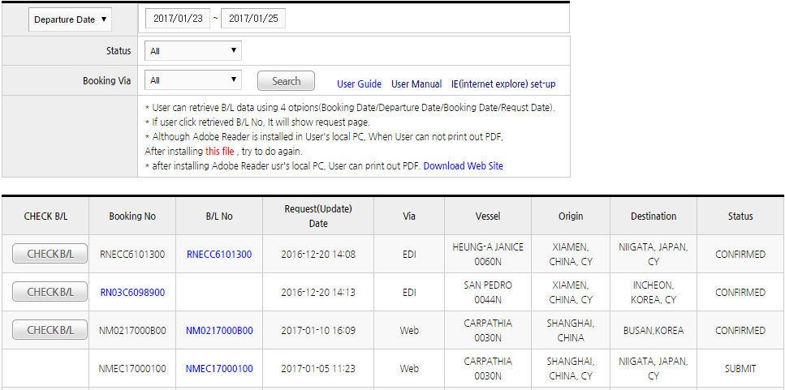

3.Main screen shoot
(CONFIRMED status=>after customer user submit S/R final confirm)
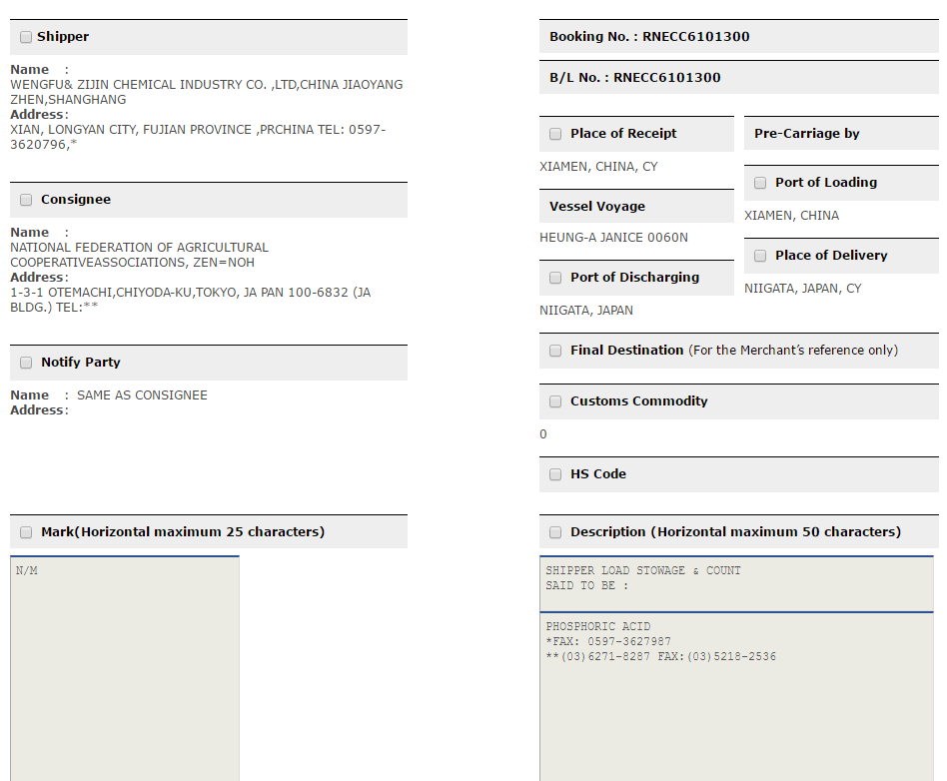

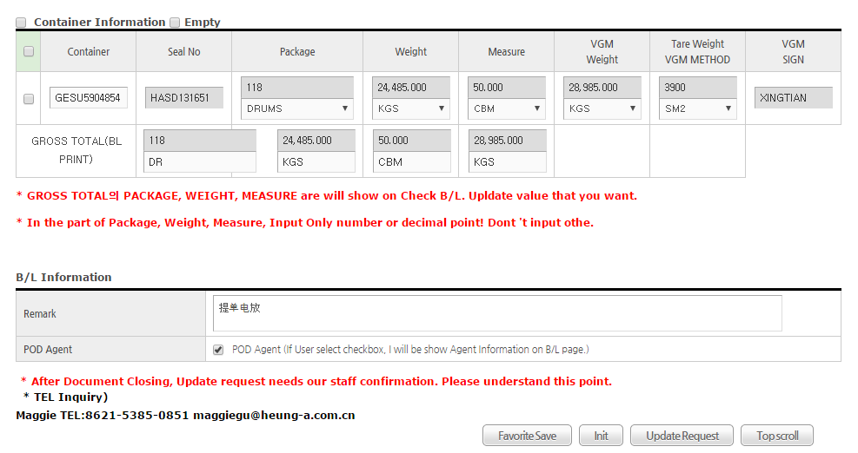
-.After final confirm (submit S/R), For updating S/R,
User have to check item’s checkbox that want to update

-.All items are same that I mentioned above explanation

-.To update item, user have to check checkbox after final confirm(submit S/R)

-.Before selecting checkbox “Shipper”
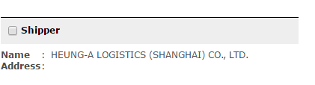

-.After checking checkbox “Shipper”
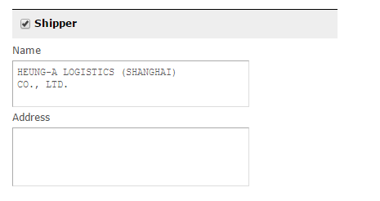

-.Shipper input line limit => name 2 lines, Address 6 lines is limited
-.Consingnee input line limit => name 2lines, Address 6 lines is limited
-.Notify input line limit => name 2lines, Address 6 lines is limited

-.After final confirm , User can not update CNTR NO/Seal NO
For updating Container information, user have to chec checkbox first of all
After user check checkbox, input item will be enabled
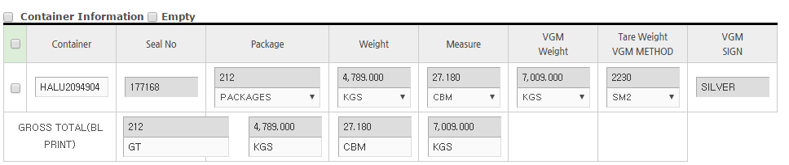
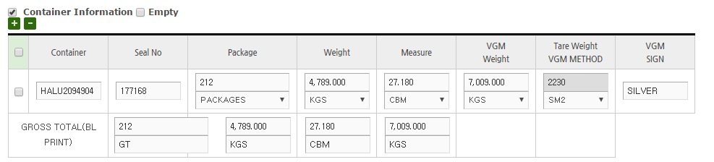


-.Favorite Save button
:When User want to save as user’s “Favorite”. Use this function

-.Init button
:If user click this button, page will be cleared

-.Update Request button
:After inputting to want update, press this button
After final confirm, If user do “Update Request”,User need to Hueng-a staff’s confirmation

-.Top scroll
:screen move to top

*.PDF related matters
-.To print out Check B/L , user have to install Adobe Acrobat Reader
-.There is problem to print out Check B/L,
re-intall the latest Abobe Reader version or update the latest Abobe Reader version
-. Down load link site => https://get.adobe.com/reader/?loc=en
-. Add "Trusted sites" at Internet Options of IE(internet explore) , and then
Change Security level to “Low”, and then
Check if Disable option at “Custom level” button’s “Enable XSS filter” item
of internet option Security tab

*.To use this webpage, user need to change internet explore option
in MenuBar -> Tools -> Compatibility View Settings
1) Add "heung-a.com" ( press "Add" button )
2)Check checkbox "Dispaly all websites in Compatibility view"
3)Press “Close” button

